

Timothy Hackworth Primary School
‘Respectful and resilient; being the best that we can be.’

Computing Policy

CRC Article 28: All children have the right to a good quality education.
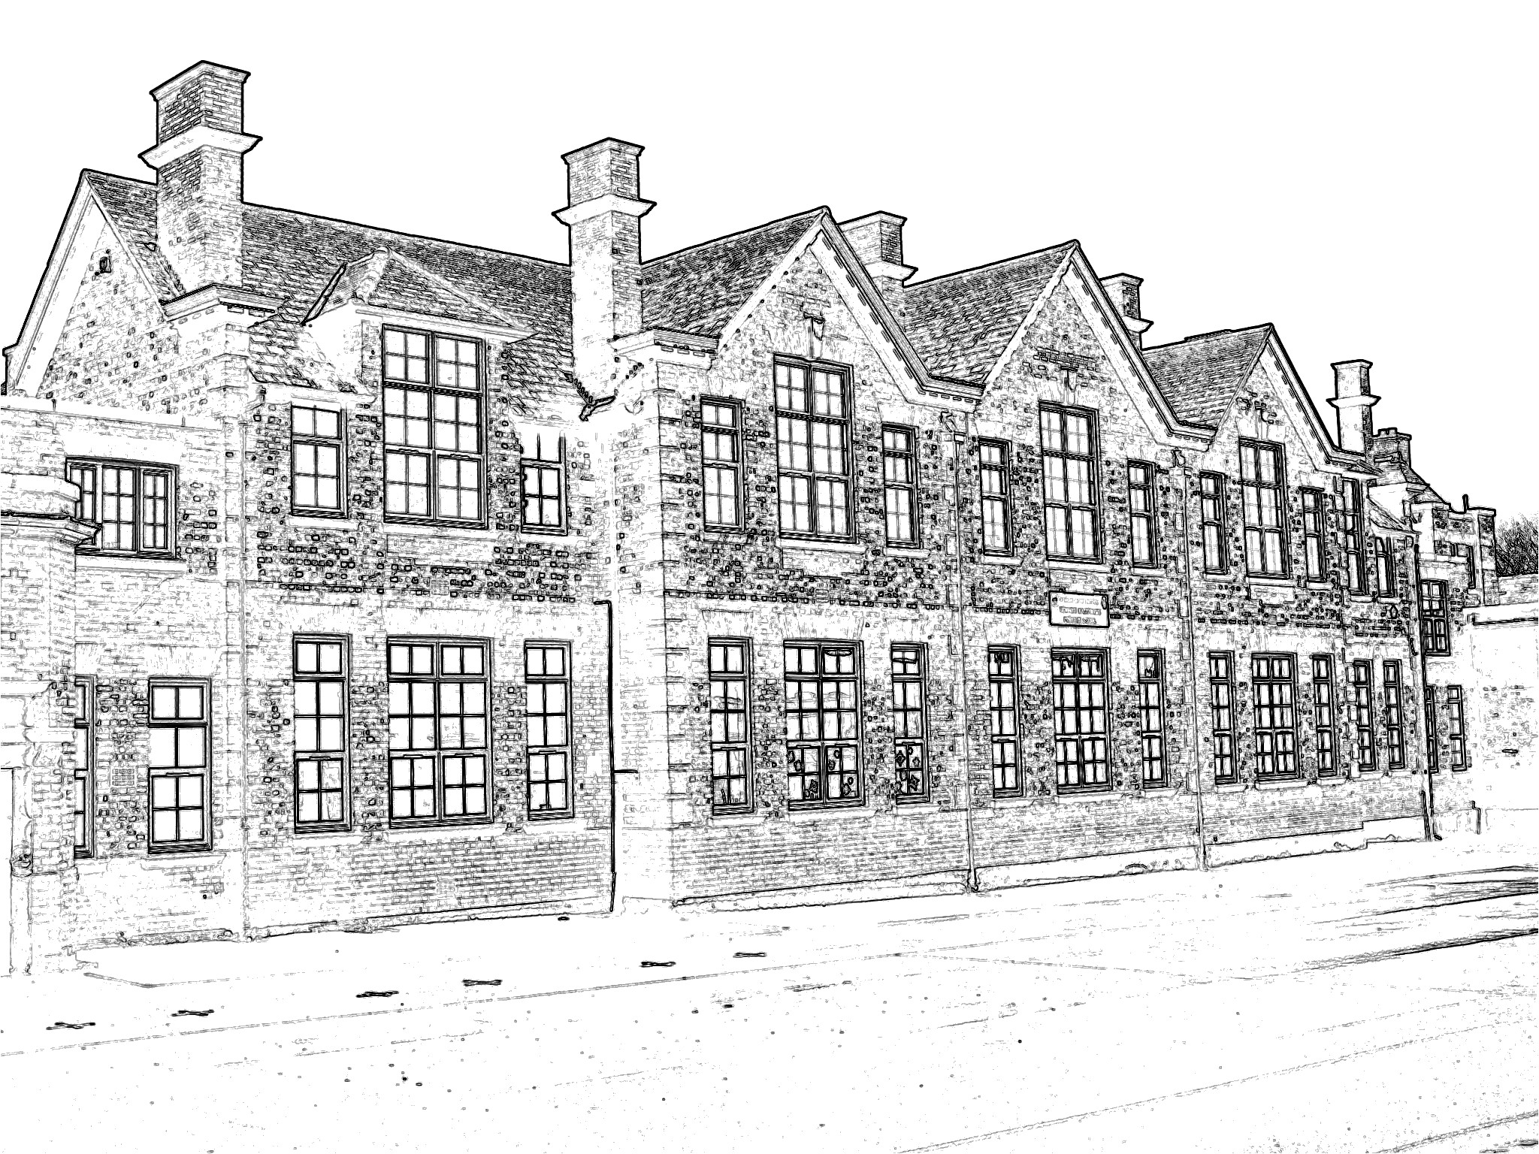
Date policy approved/adopted: | February 2024
Next review date: | February 2025
Approved by: | Curriculum and Standards Committee
Head Teacher signature: | Mrs. L. Boulton
Chair of Governors signature: | Mrs. P. Crook

Computing Policy

CRC Article 28: All children have the right to a good quality education.

Date of Policy: February 2024

Review Date: February 2025

Subject Lead: Miss M. Curbeson

Governors for Computing: Mrs. P. Crook
Curriculum and Standards Committee
This policy should be read in conjunction with our Respectful Relationships Policy, Online Safety Policy, Data Protection Policy, Anti-Bullying Policy, Acceptable Use Policy and the PSHE incorporating Relationships Education Policy. All policy and practice in Timothy Hackworth Primary School respects children’s dignity.

Our Timothy Hackworth School Vision
May our Rights Respecting School be a happy place for us all to learn; where every one of us is valued and safe in our Timothy Hackworth School Family. May we all be the best that we can be by making a positive difference to each other, our community in Shildon and the wider world in which we all live.

Mission Statement (written by children):
We would like our school, which reflects British Values, to be at the heart of the community, sharing, supporting and learning together with everyone as equals. Our children have the right to high quality learning experiences to help them to be the best that they can be.

We encourage our children to be creative, unique, open-minded and independent individuals, respectful of themselves and of others in our school, our local community and the wider world.

We aim to nurture our children on their journey through life so that they can grow into safe, caring, democratic, responsible and tolerant adults who make a positive difference to British Society and to the world.

Values
Ours is a happy school with high hopes and ambitions for all our children and we welcome working in partnership with parents and carers to ensure that everything is done in the best interests of the children at all times.

All of our staff take their responsibility towards the children seriously and they strive to help each child reach their full potential as global citizens physically, emotionally, socially and academically. We are fully committed to the CONVENTION ON THE RIGHTS OF THE CHILD.

To us, every child is unique and precious and we endeavour to foster a high level of motivation towards learning and behaviour. We are committed to the basic skills of English and Maths.

At all times, we aim to centre the teaching in an atmosphere of mutual respect and personal respect. A high quality education is the right of every child, and at Timothy Hackworth Primary School, we embrace that responsibility and strive to achieve it for all our pupils.

Equalities Information
This policy should be read in conjunction with our school’s ‘Equalities Policy Statement’, ‘Equalities Objectives Summary’ and ‘Equalities Information and Objectives’.

We welcome our duties under the Equality Act 2010 to eliminate discrimination, advance equality of opportunity and foster good relations in relation to age (as appropriate), disability, gender reassignment, marriage and civil partnership, pregnancy and maternity, race, religion or belief, sex and sexual orientation.

Rationale
At Timothy Hackworth Primary School, we aim to inspire all children to reach their full potential, academically, socially and emotionally. In Computing, this means ensuring a curriculum that is fully inclusive of all children.

As technology is an integral part of everyday life, we at Timothy Hackworth, feel that each child should experience all aspects of technology; from the use of computers and laptops, to exploring tablets and other technical devices. We intend to expose children to different uses of technology that they may not experience outside of school, and ensure that we are challenging their technology-based skills. We want to ensure that children build up a bank of technology-based vocabulary, alongside a clear understanding of it, which will allow them to function confidently within an ever more technology-focused world.

We recognise that children have an increasing access to a range of technologies, including the internet. Due to this, children need to have a developing understanding and awareness of ever-changing issues relating to Online Safety (see our Online Safety Policy) as they progress through the school. From this, children will be able to make appropriate choices in taking the steps necessary to make sure that they are safe and supported if things go wrong.

Entitlement
This Computing Policy relates to all pupils attending Timothy Hackworth Primary School.

All children have the right to access all elements of the National Curriculum, appropriate to their abilities, in tandem with the school’s relentless focus on high standards and expectations of all pupils.

Our Intent, Implementation and Impact in Computing

Intent
All pupils at Timothy Hackworth Primary School have the right to rich, deep learning experiences that incorporate all aspects of Computing. With technology playing such a significant role in society today, we believe that ‘Computational Thinking’ is a skill that children must be taught, at a level suitable for the future workplace, so that they are able to participate effectively and safely in this digital world.

Pupils will:
• understand and apply the fundamental principles and concepts of Computer Science, including abstraction, logic, algorithms and data representation;
• analyse problems in computational terms, and have repeated practical experience of writing computer programs in order to solve such problems;
• evaluate and apply information technology, including new or unfamiliar technologies, analytically to solve problems;
• be responsible, competent, confident and creative users of information and communication technology.

Our Computing curriculum is centred on children knowing how to access and use technology around them, but, fundamentally, how to keep safe both online and off-line, and be respectful at all times. This will start with our youngest children and continue throughout their time at Timothy Hackworth Primary School. Children have the right to be both physically and mentally healthy.

We strive to ensure that our pupils have the opportunity to demonstrate resilience, resourcefulness, reflectiveness and reciprocity and have the ambition to be successful learners.

Implementation
Our Computing curriculum allows children to build up a broad and balanced knowledge base through experiencing computing in two phases. First, is through the teaching of discrete computing skills where children learn how to investigate and program devices, use technology to communicate information in the form of words and graphics, use the Internet safely and effectively, handle data, store, and sort and retrieve information. Secondly, the children are provided with opportunities to use computing in other subject areas. They are encouraged to think about how computing can support their learning across the curriculum by using and applying the skills which they have learnt.
Our school ensures consistency and progression through the provision of a well-sequenced curriculum. A variety of resources are used, including apps and software, for example, Microsoft programs, Scratch, Alex, Bee-Bots and Kodu. We ensure that children develop depth in their knowledge and skills throughout each computing unit.

We have a variety of hardware resources to support learning, both in Computing lessons and across the curriculum. The children have access to a range of computing devices to support their learning such as iPads, laptops, Bee-Bots, Pro-bots and micro:bits. Within our school, there is an interactive whiteboard in each classroom and wireless internet connection across the entire school. As a result of investing in a significant amount of devices, children’s learning in the Computing curriculum is effectively provided for. It has enabled the provision of a wide range of opportunities to enhance the development of skills, and access to a wealth of information across the primary curriculum.

The Computing Curriculum Overview has been developed with planned units that are carefully sequenced to ensure progression. They provide exciting, realistic, engaging and creative learning experiences, which promote life skills.

Evidence of learning is stored electronically and as part of our Black Books.

Early Years Foundation Stage
Our children are provided with a broad, play-based experience of Computing in a range of contexts, including outdoor play. Computing is not just about computers. Early years learning environments feature Computing scenarios based on experience in the real world, for example, through role-play. Children gain confidence, control and language skills through opportunities to explore, using non-computer based resources such as metal detectors and Bee-Bots. Recording devices support children to develop their communication skills.

KS1 and KS2
The topics studied in Computing are planned to build upon prior learning. Children develop their skills and knowledge in each unit. Progression is built into the sequence of learning so that the children are increasingly challenged as they move up through the school.

Computing is taught in Key Stages 1 and 2 through high quality Computing lessons that engage and inspire children in three areas: Computer Science, Information Technology and Digital Literacy.

Computer Science
Computer Science is the foundation. It is the core of Computing where our pupils are taught how digital systems work, and how to use this knowledge to program. They learn the principles of computation and information.

Pupils are taught the principles of:
- How computer systems work;
- Finding and fixing mistakes in a program (de-bugging);
- Using logical thinking to solve problems;
- Sequencing instructions (algorithms) to make something happen (programming).

Information Technology
Information Technology is the application. Children use their Computer Science knowledge to create programs, systems and content.

Pupils have the knowledge to:
- Create programs;
- Create content;
- Store and manipulate content;
- Retrieve digital content (searching).

Digital Literacy
Digital Literacy are the implications. Children become digitally literate to use and develop their ideas through Information Technology. This will enable them to become active members of the future workforce.

Pupils will become digitally literate so that they are:
- Prepared for the future workplace;
- Responsible and safe users;
- Competent, confident and evaluative.

As part of our Computing Curriculum Overview, each half term has a distinct focus on either Computer Science or Information Technology. Digital Literacy is taught continually throughout the term.

There are further opportunities for children to develop their Digital Literacy skills throughout the year, for example, during assemblies, Family Groups and special days, for example, Safer Internet Day, and through the ‘Digital Leaders’ group.

Cross-curricular links are appropriately made in other subjects, where Computing skills are applied.

Children are taught how to use technology safely by following the correct health and safety procedures.

Impact
Knowing more, remembering more and being able to do more are indicators of progress. Children should be prepared for their next stage of learning.

Impact is measured by the child’s progress against their expected outcomes and their ability to meet the key aims of the National Curriculum for Computing.

Pupils will be able to:

- Design, write and de-bug programmes that accomplish specific goals, including controlling or simulating physical systems; solve problems by decomposing them into smaller parts;
- Use sequence, selection and repetition in programs; work with variables and various forms of input and output;
- Use logical reasoning to explain how some simple algorithms work and to detect and correct errors in algorithms and programs;
- Understand computer networks, including the internet; how they can provide multiple services, such as worldwide web; and the opportunities they offer for communication and collaboration;
- Use search technologies effectively, appreciate how results are selected and ranked, and be discerning in evaluating digital content;
- Select, use and combine a variety of software (including internet services), on a range of digital devices to design and create a range of programs, systems and content that accomplish given goals including collecting, analysing, evaluating and presenting data and information;
- Use technology safely, respectfully and responsibly; recognise acceptable and unacceptable behaviour; identify a range of ways to report concerns about content and contact;
- Enjoy using technology to develop their learning and ideas;
- Apply British Values and our school Rights Respecting ethos to ensure they use technology safely and respectfully at all times;
- Become more independent and use key life skills such as problem-solving, logical thinking and self-evaluation.

After the implementation of this robust Computing curriculum, children at Timothy Hackworth Primary School will have developed the knowledge, skills and understanding to help them access and use a range of technology in a safe and creative way.
Children’s skills will have progressed to enable them to not only have met the requirements of the National Curriculum but to also enjoy using technology to develop their own ideas. From this, they will become more independent and key life skills such as problem-solving, logical thinking and self-evaluation will become second nature.

More Able and Talented Learners
The Computing Lead will promote the following key strategies for maximising progress and enabling learners to meet their full potential:

- The use, by all, of open-ended questioning, where a learner’s first response may then be further developed and so encourage deeper thinking;
- Valuing a growth mindset that encourages learners to risk failure. Instead, viewing it as a crucial part of the learning process that avoids the pitfalls of playing it safe, and success meaning only doing things that they can get completely right or find easy;
- Encouraging the provision of open-ended opportunities for learners to take more ownership of the direction or form that their learning takes;
- Praising high levels of effort, progress and attainment whilst making sure that a focus on the next steps is a valued part of the ongoing learning process.

Special Educational Needs and Disabilities
Pupils with special educational needs and disabilities have the same computing entitlement as all other pupils and are offered the same curriculum. However, particular applications and tools are used for:
- Pupils with learning difficulties who need to be motivated to practise basic skills regularly and intensively;
- Pupils with physical disabilities and communication difficulties.

Assessment
We consider that assessment is part of the whole school curriculum. It is the responsibility of all staff and should provide a supportive framework for teachers and children.

Assessment is not just about the National Curriculum, but needs to take into consideration all Computing learning which is an outcome of the school curriculum.

There is ongoing assessment for learning (AFL), formative assessment and summative assessment of all children, ensuring that the development of concepts, skills and attitudes is measured through everyday teaching in a variety of contexts.

Teachers will need to make judgements about children’s abilities. The judgements must be supported by evidence which can be understood by other teachers, by parents and by the children themselves. Evidence of ability will be demonstrated by children in the course of their learning.

The impact of learning will be assessed using:
- Teacher assessment;
- Monitoring by the Computing Lead and through learning walks, planning,
work scrutinies and pupil interviews;
- Information that is gathered regularly from staff, parents and children to evaluate the effectiveness of the learning and experiences we provide and how we can develop further.
Monitoring and Evaluation
The monitoring of Computing teaching and learning in our school will take place through the:

- monitoring of short term planning by the Computing Lead;
- observations and Learning Walks by the Computing Lead and SLT where appropriate;
- discussion during curriculum development staff meetings in order to further develop provision and practice, respond to queries, check progress, review resources etc.;
- informal discussions between staff and the Computing Lead;
- the completion of any whole school Computing project where work/evidence is gathered, across the whole range of ages in the school;
- scrutiny of files, displays and any other evidence of achievement, by the Computing Lead and SLT;
- pupil interviews conducted by the Computing Lead;
- checking of children’s standards of work against agreed criteria e.g. teacher assessment.

Teacher assessments are moderated by the Subject Lead to ensure parity.

The Computing Lead works alongside teachers to provide tailored support to discuss, plan and implement a range of assessment and moderation strategies.

Continuing Professional Development
The Computing Lead continues to attend Local Authority Subject Leader Network Meetings in order to ensure that the Computing Lead and wider staff are aware of the latest information and curriculum developments in Computing.

Staff are also provided with regular, planned, internal and external CPD opportunities where relevant and as appropriate.

Display and Resources
Our school ‘Climate for Learning in Classrooms’ document, outlines the resources and display requirements for each classroom, which includes reference to resources and displays to support pupils’ learning.

Our Governing Body
The Governing Body will provide support and challenge and are kept up to date with developments in Computing through meetings with the Computing Lead, through the Head Teacher’s Report to Governors, subsequent discussions during Full Governing Body Meetings and Curriculum and Standards Committee Meetings.

The Governing Body will be provided with regular updates regarding the implementation and monitoring of this policy.

The Curriculum and Standards Committee will ratify and review the policy.

Maintenance
Maintenance is carried out by our school’s contracted Shared Engineer, who visits the school twice a week to give technical support and maintain the network to its optimum capability.

Health and Safety
Timothy Hackworth Primary School is aware of the health and safety issues involved in children’s use of IT and Computing. All electrical equipment is PAT tested. All staff should visually check electrical equipment before its use and remove any damaged equipment, which should be reported to the technician or SLT.

When working with tools, equipment and materials, in practical activities and in different environments, including those that are unfamiliar, pupils should be taught:
- to never to look into the projector lens;
- the appropriate and safe use of all equipment, especially scanners, and photocopiers due to the bright lights.

Reporting
Information about children’s progress with regard to Computing is communicated to parents during parent consultation meetings and as part of pupils’ individual annual reports.

Conclusion
At Timothy Hackworth Primary School, a whole range of experiences and opportunities will be provided for all pupils across a broad and balanced curriculum which reflects school, local, national and global perspectives.

The curriculum offer is routinely reviewed to monitor its Intent, Implementation and Impact.

All children have the right to a high quality education; our Computing Policy is designed to ensure that all pupils have access to this right.

